CO2 ASSESSMENT TOOL 2
ARCHITECTURE DESIGN ASSIGNMENT

1. System Requirement Analysis
The Intelligent Disaster Emergency Response Platform coordinates emergency reports, affected locations, rescue teams, medical resources, shelters, and relief supplies during floods, earthquakes, cyclones, and other disasters. It provides one shared source of information so that urgent incidents can be identified and handled quickly.
1.1 System Objectives
Register incidents and capture their location, type, severity, and current status.
Prioritize requests using severity rules, giving life-threatening cases the highest priority.
Track rescue teams, medical units, supplies, and their availability.
Show shelter locations, capacity, accessibility, and available supplies.
Provide real-time dashboards, notifications, and response reports.
Maintain secure, accurate records for coordination and post-disaster analysis.
1.2 Functional Requirements
FR1 – User access: Citizens, dispatchers, rescue teams, and coordinators sign in with role-based permissions.
FR2 – Incident reporting: Users submit incident type, description, location, severity indicators, and optional supporting details.
FR3 – Incident mapping: The system displays incident locations and affected zones on a map.
FR4 – Smart prioritization: The priority engine scores requests using severity, risk to life, number of people affected, and urgency.
FR5 – Resource coordination: Dispatchers view team availability, assign suitable teams, and update dispatch and arrival status.
FR6 – Shelter management: Coordinators maintain shelter location, capacity, occupancy, accessibility, and supply information.
FR7 – Notifications: The system sends status updates and urgent alerts through push notifications, SMS, or email.
FR8 – Monitoring and reports: Dashboards show open incidents, response time, resource usage, shelter occupancy, and resolved cases.
FR9 – Audit history: Important actions and status changes are recorded with time and user details.
1.3 Non-Functional Requirements
Scalability: Support a sudden increase in incident reports and users during a major disaster.
Availability: Keep core reporting and dispatch functions accessible during emergencies.
Performance: Display incident status quickly and prioritize urgent requests with low delay.
Reliability: Avoid losing reports; preserve consistent records and recover from service failures.
Security and privacy: Use authentication, role-based access, encryption, and audit logs to protect personal and location data.
Maintainability: Keep components separate so that one service can be updated without redesigning the whole platform.
Usability and accessibility: Provide clear, mobile-friendly screens and simple reporting steps for stressed users.
Interoperability: Connect to map, weather, alerting, and government/emergency systems through documented APIs.
1.4 Quality Attributes Influencing Architecture
The most important attributes are availability, reliability, scalability, security, and performance because the platform supports time-critical emergency operations. Maintainability and interoperability are also important because response rules, external data sources, and disaster needs may change.
2. Selection of Suitable Software Architecture
Selected architecture: Hybrid architecture combining a service-oriented/microservices structure with an API gateway and event-driven communication.
The platform is divided into independently managed services such as Incident Management, Priority Engine, Resource and Team Coordination, Shelter Management, Notifications, and Analytics. Web/mobile clients access these services through an API Gateway. REST APIs handle direct requests, while asynchronous events or a message queue distribute time-sensitive updates and alerts.
Why this architecture is suitable
Independent scaling: incident intake and notifications can scale separately during a disaster surge.
Fault isolation: a failure in analytics should not stop incident reporting or dispatch.
Fast event handling: a new high-severity incident can trigger prioritization, dispatcher updates, and alerts.
Clear separation of responsibilities: each service owns a defined function and can be tested independently.
Integration support: external map, weather, SMS, and emergency systems can connect through APIs.
Future growth: new services, such as volunteer coordination or damage assessment, can be added with limited changes.
A layered design is used within each service (presentation/API, business logic, and data access), making the overall solution hybrid rather than relying on a single architectural style.
3. Software Architecture Diagram
The diagram shows the client interfaces, API Gateway, core services, data stores, and external integrations. Arrows represent the main request and data flows.
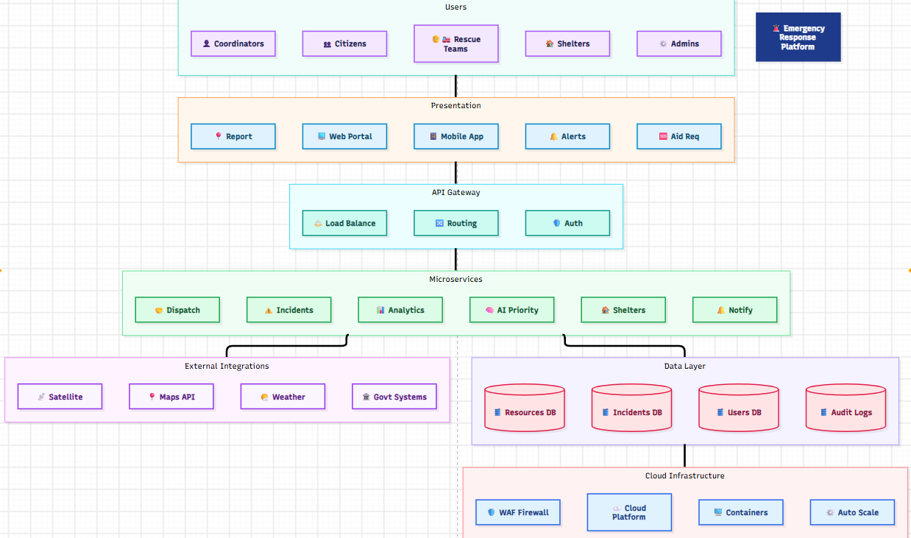

Figure 1. Hybrid service-based architecture for the Intelligent Disaster Emergency Response Platform.
4. Components and Their Interactions
4.1 Citizen Mobile/Web Application – Allows affected people to submit incidents, share location, request aid, check status, and find nearby shelters.
4.2 Rescue Agency Portal – Allows dispatchers and rescue teams to review incidents, accept assignments, update progress, and report completion.
4.3 Coordinator Dashboard – Shows live incident maps, resource availability, shelter occupancy, priority queues, and operational reports.
4.4 API Gateway / Load Balancer – Provides a single entry point, routes requests to the correct service, applies authentication and rate limits, and distributes traffic.
4.5 Incident Management Service – Validates reports, assigns incident IDs, stores incident details, updates status, and provides location information.
4.6 Priority Engine – Applies configurable severity rules and ranks incidents. Life-threatening cases and high-risk locations receive urgent attention. Final dispatch decisions remain with authorized personnel.
4.7 Resource and Team Service – Maintains team skills, location, availability, medical units, supplies, assignments, and dispatch status.
4.8 Shelter Management Service – Tracks shelter location, capacity, occupancy, accessibility, and essential inventory.
4.9 Notification and Analytics Service – Sends alerts and status updates and calculates response-time, incident-volume, and resource-utilization metrics.
4.10 Operational Relational Database – Stores users, incidents, requests, teams, assignments, shelters, and structured operational records.
4.11 Geospatial / Map Data Store – Stores coordinates, affected zones, and location-related data used for maps and routing.
4.12 Audit and Analytics Store – Stores event history, access logs, status changes, and aggregated metrics for monitoring and review.
4.13 External Integrations – Map/GIS services provide maps and geocoding; weather/disaster APIs provide hazard information; SMS/email/push providers deliver alerts.
4.14 Main Workflow
1. A citizen submits an incident through the mobile/web application, including location and details.
2. The API Gateway authenticates the request and forwards it to the Incident Management Service.
3. The service validates and saves the incident, then publishes an IncidentCreated event.
4. The Priority Engine evaluates severity and updates the priority queue.
5. The Resource and Team Service identifies available, suitable teams; an authorized dispatcher confirms assignment.
6. The Notification Service alerts the assigned team and relevant coordinators. The citizen receives status updates when appropriate.
7. Shelter information is checked when evacuation or accommodation is required; occupancy is updated as people arrive.
8. Dashboards display status changes and performance measures. Audit records preserve the action history.
Communication and Data Exchange
Client-to-service communication uses HTTPS and REST APIs with structured JSON data. Services publish events such as IncidentCreated, PriorityUpdated, TeamAssigned, and ShelterCapacityChanged to a message queue. Subscribers process these events asynchronously, reducing delays and preventing one slow service from blocking the entire workflow. Database access is restricted to the responsible service wherever practical.
5. Quality Attribute Evaluation
Scalability: Run multiple instances of high-demand services behind a load balancer. Scale incident intake and notification workers independently. Cache frequently requested read-only data where safe.
Security: Use HTTPS/TLS, secure sign-in, role-based access control, least-privilege permissions, input validation, encrypted sensitive data, audit logs, and regular backups. Share only the minimum personal data required.
Performance: Use indexed incident and location fields, efficient queries, asynchronous notifications, caching for common map/shelter data, and a priority queue for urgent cases.
Reliability: Use database transactions, retries with limits, idempotent event handlers, message persistence, health checks, backups, and tested recovery procedures to reduce data loss and duplicate actions.
Maintainability: Keep services modular, document APIs, use automated unit/integration tests, centralize configuration, and maintain clear service ownership. Changes to shelter rules need not change incident reporting.
Availability: Deploy critical services redundantly, monitor health, use automatic restart/failover where supported, maintain backup communication channels, and provide disaster-recovery procedures.
6. Architectural Justification and Trade-offs
6.1 Main Architectural Decisions
Separate core services: Incident, priority, resource, shelter, and notification functions have different workloads and responsibilities, so separating them improves modularity and independent scaling.
API Gateway: A single controlled entry point simplifies routing, authentication, rate limiting, and API monitoring.
Event-driven updates: Events allow notifications and dashboards to react to changes without making the incident-reporting request wait for every downstream operation.
Relational plus geospatial data: Relational storage supports consistent operational records; geospatial capabilities support location searches, affected-area maps, and routing.
Human-supervised prioritization: Rules help surface urgent cases consistently, but authorized dispatchers can review recommendations to handle incomplete or unusual reports.
6.2 Trade-offs and Mitigation
Greater deployment complexity: Multiple services require monitoring and deployment coordination. Mitigation: use containerized deployment, CI/CD, centralized logs, and service health dashboards.
Eventual consistency: A dashboard or notification may update slightly after the database changes. Mitigation: show timestamps/status, use reliable event delivery, and keep the authoritative incident record in the operational database.
Network dependency: External map or messaging providers may fail. Mitigation: use timeouts, retries, provider fallback where possible, and allow core incident registration to continue.
Security across services: More service interfaces create more points to protect. Mitigation: secure service-to-service communication, least privilege, secrets management, and audit monitoring.
6.3 Future Enhancements
Add multilingual voice-based incident reporting and accessibility support.
Integrate satellite imagery, IoT sensors, and verified weather alerts for better situational awareness.
Use historical response data to improve prioritization recommendations, with human review and fairness checks.
Add volunteer registration, relief distribution tracking, and damage assessment services.
Support multi-region deployment and offline-first mobile reporting for areas with weak connectivity.

The proposed hybrid service-based architecture meets the platform's need for fast, secure, reliable, and scalable disaster coordination. The API Gateway controls access, independent services manage key operations, event-driven communication distributes urgent updates, and structured plus geospatial data stores support accurate decisions. Redundancy, security controls, monitoring, and modular design help the platform remain maintainable and ready for future enhancements.

